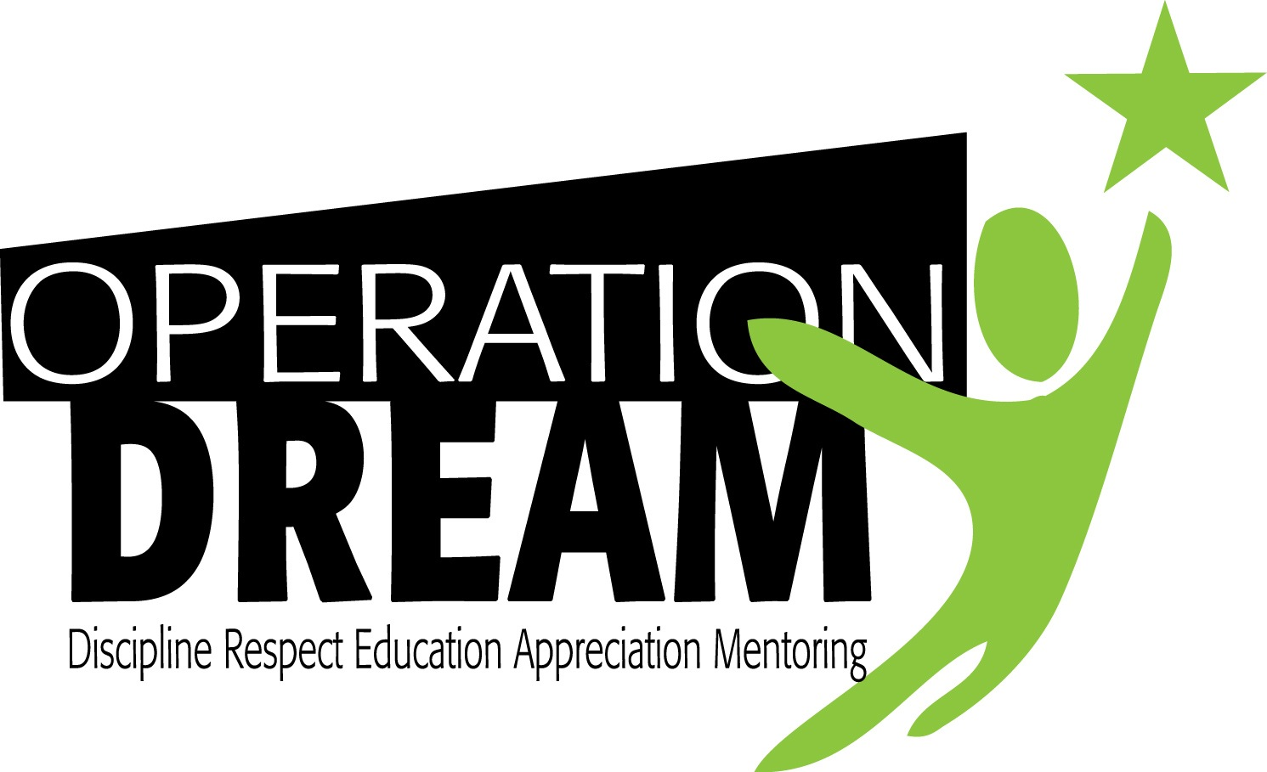
Director of Administration
Updated 7/25/19

Human Resources:

- Promote OD positions on career and social media platforms in an effort to recruit the right candidate for open position(s)
- Update job descriptions in coordination with ED
- Work with ED on scheduling interviews for prospective candidates
- Work with ED to onboard new hires covering all new hire paperwork including payroll, insurance eligibility, background check, and reference checks
- Organize and maintain all internal files for staff
- Schedule annual performance reviews for staff as directed by ED
- Conduct annual background, drug testing and insurance reviews for staff

Finances:

- Work with ED and accountant to track receipts and expenses and provide accountant with support needed to complete monthly reconciliation of credit card expenses by staff
- Coordinate bi-weekly payroll submission with accountant to ensure that all timesheets are prepared for processing
- Work with ED and accountant to resolve payroll issues as they arise
- Track and report transportation expenses to ED
- With oversight by ED, oversee accounts payable and receivables

Programming:

- Attend program meetings to determine transportation needs and update Director of Programs on issues or concerns related to parents or youth
- Coordinate transportation needs of OD for all programs and driver’s
- Work with transportation vendor and or OD staff (driver’s) to efficiently establish transportation needs for all programs
- Communicate to parents via email, call-em-all, phone, mailings or face to face to resolve any issues or concerns that may arise
- Provide data entry support for inputting program applications into organizational database (ProCare)
- Run reports for individual programs as needed using organizational database
- Monitor enrollment in all programs and reporting information upon request and at established program meetings
- Monitor upkeep of vehicles records, maintenance, vehicle registration, cost and accountability of driver’s utilizing organization owned vehicles
- In coordination with the Director of Programs oversee shopping for Operation DREAM programs as needed.
- Facilitate volunteer process by communicating with prospective volunteers on process, overseeing volunteer application and background checks, communicating status of volunteers Director of Programs and ED.

Donor/Development and Board Relations:

- Send out correspondence to Board members or donors as needed
- Assist with scheduling and preparing for board meetings throughout the year
- Assist with planning and executing mass mailing initiatives
- Manage Little Green Light donor database
- Prepare Acknowledgement Letters

Office Management:

- Open and close office daily from 9am-5pm
- Maintain upkeep of office space
- Answer phones directing messages to appropriate receiver
- Keep Google contact list up to date
- Check and distribute mail to appropriate receiver
- Ensure office supplies are available and replenished when needed
- Update organizational calendars

The right candidate will:

- Have a passion for seeing young men of color become successful and a commitment to the mission of the organization
- Be personable attitude and positive demeanor
- Be a team player
- Be able to communicate with a variety of audiences and stakeholders
- Be able to navigate organizations database and pull reports
- Be proficient in Microsoft word, excel and PowerPoint
- Be an innovative thinker and have a willingness to share ideas at the highest level
- Have leadership qualities that will garner support while also being able to make tough decisions

The ideal candidate will:

- Have experience working in the nonprofit sector serving underserved of disadvantaged demographic
- Has a network of resources and opportunities that could benefit OD
- Sees themselves as a contributor to the organization at a high level
- Be flexible as things change within the organization
- Be willing to do whatever is needed to enhance the organizational efficiency and opportunities offered to our young men
- Be reliable and self-motivated.
- Have a good communication skills.
- Have a superior problem solving skills.
- Have strong leadership qualities.
- Be a strategic thinker.
- Have Budget management experience.
- Have people-management skills.
- Have exceptional organizational skills.

To apply: Complete online application at https://www.operation-dream.org/jobs and submit a copy of your cover letter and resume; salary expectations; and 3 professional references to Marco.morrison@operation-dream.org.

